**STORAGE AREA NETWORKS**

**CENG 505 PARALEL COMPUTİNG 1**

**Murat ALTUN**

**200871207**

**A SAN (Storage Area Network) is a network designed to transfer data from servers to targets, and it is alternative to a directly attached target architecture, or to a DAS (direct attached storage) architecture, where the storage is connected to the servers on general purpose networks. Additional definitions of a SAN imply that the SAN should also be highly performing, and should be such to enable storage devices to communicate with one another and with computer systems.**

**Different technologies can be used to interconnect the network nodes, extending the Disk interface outside the server. Fiber Channel is a dedicated channel based high performance and highly available network based on Fiber Channel Protocols. iSCSI is SCSI protocol carried over an IP network. In this case the network infrastructure can be shared with other applications. SCSI network is an extension of the internal SCSI bus, used for short distances due to its parallel architecture .**

**Fiber Channel Node: can be the source or the destination of information If the node is an Initiator (source), it is usually connected to the network via an HBA (Host Bus Adaptor), which is the physical connection interface, and can be based either on electrical or (more often) optical technology. If the node is a target (destination), it can be a JBOD (Just a Bunch of Disks), a RAID (Redundant Array of Independent Disks), or a Storage array.**

**While a Jbod is a group of disks packaged in an enclosure and connected via a FC loop, a RAID is a more sophisticated device, that may improve performance and/or reliability of the storage device which is improving performances reading/writing information from a set of disks at the same time, and reliability adding parity and/or mirroring information on multiple disks of the array and can be performed in HW via a controller embedded in the enclosure or software on the host.**

**SAN is the convergence of an almost-error-free, very reliable interface and the advantage of a networking infrastructure. It takes advantage of a controlled and reliable data transfer interface and adds the capability of switching and sharing proper of the networks.**

**RAID (redundant array of independent disks; originally redundant array of inexpensive disks) is a way of storing the same data in different places (thus, redundantly) on multiple**[**hard disk**](http://searchstorage.techtarget.com/sDefinition/0,,sid5_gci212227,00.html)**s. By placing data on multiple disks,**[**I/O**](http://searchcio-midmarket.techtarget.com/sDefinition/0,,sid183_gci214007,00.html)**(input/output) operations can overlap in a balanced way, improving performance. Since multiple disks increases the mean time between failures (**[**MTBF**](http://whatis.techtarget.com/definition/0,,sid9_gci212607,00.html)**), storing data redundantly also increases**[**fault tolerance**](http://searchcio-midmarket.techtarget.com/sDefinition/0,,sid183_gci214456,00.html)**.**

**There are lots of array systems but most famous raid systems are RAID 0,1,5.**

1. **RAID 0 or striping**

|  |  |
| --- | --- |
| **striping** | **Data are split onto different disks for performance increase and performances depend on information unit size vs stripe size.No redundancy added and**  **cost is limited (no additional hardware)** |

1. **RAID 1 or mirroring**

|  |  |
| --- | --- |
|  | **Data are replicated on multiple disks for redundancy. Performance may be impacted if copy is done serially butcost increases proportional to the amount of redundancy.**  **More complex algorithm to manage multiple copies** |

1. **RAID 5 or parity calculation**

|  |  |
| --- | --- |
|  | **Data protection with ECC, but parity is spread on the array. It is good for redundancy and speed reads, slower writes.**  **One disk cost addes per array.** |

**SAN architecture**

**Storage is accessed at block level not at file level. SAN serves very high performance, shared storage environment and has good management tools.**

**SAN has 3 common architectures like:**

* **Point to point is the simplest topology for very limited connectivity needs and It guarantees in order delivery and full bandwidth access.The application can handle any multipath connectivity to a set of disks in case this is provided, since no other elements are present in this topology**

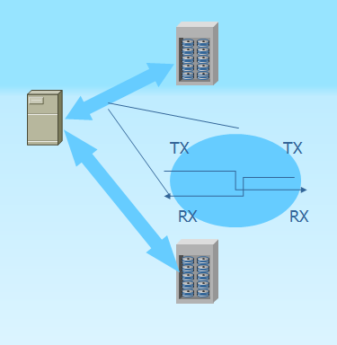

* **Arbitrated Loop Designed to scale to a limited number of nodes (up to 127) has advanteges lile low cost (no interconnecting devices needed). Arbitration protocol is designed to manage media sharing across nodes; may be disruptive when a node gets added/removed from loop and loop initialization protocol kicks in . An arbitrating hub can be used instead of a distributed protocol.**

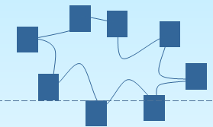

* **Switched Fabric designed to extend the device sone to other as star topology. System can expend by adding switches and reliability can be obtained by using two switches for every node.**

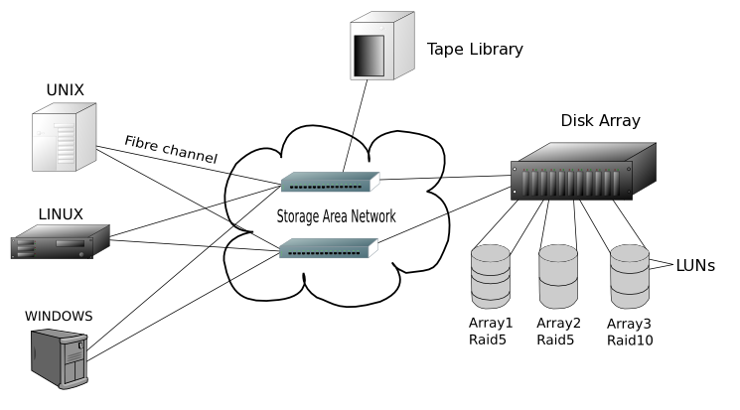

**REFERENCES:**

1. Resilient Storage Networks Greg SCHULZ ISBN: 1-55558-311-3 Elsevier Digital Press
2. Designing Storage Area Networks Tom CLARK ISBN: 0-321-13650-0 Addison Wessley
3. Information Systems Transformation Philip H. Newcomb ISBN: 978-0-12-374913-0 Elsevier Digital Press