

Main report submitted to
the Department of Computer Engineering of Çankaya University
in partial fulfilment of the requirement for
CENG 505 Parallel Computing I
Term Project

CENG 505 Parallel Computing I

TERM PROJECT

By

201072002Nizamettin Doğan GÜNER

Date: 21/01/2011

HONOR CODE

I hereby declare that, except where I have indicated, the work I am submitting in this report is my own work.

Student Name | Signature
Nizamettin Doğan GÜNER

LIST OF CONTENTS

1. WHAT IS A SUPERCOMPUTER? 1
2. HARDWARE AND SOFTWARE DESIGN OF SUPERCOMPUTERS 2
2.1 Supercomputer Challenges 2
2.2 Technologies 3
2.3 Processing Techniques 3
2.4 Operating Systems 3
2.5 Programming and Software Tools 4
3. MODERN SUPERCOMPUTER ARCHITECTURE 4
4. THE FASTEST SUPERCOMPUTERS TODAY 5
4.1 TOP500 List Project 6
4.2 Current Fastest Supercomputer 7
REFERENCES 8

LIST OF FIGURES

Figure 1. A Typical Supercomputer 1
Figure 2. Operating Systems Used in Supercomputers 3
Figure 3. Fastest Supercomputers: log speed vs. years 5
Figure 4. Classification of Supercomputers by Speed 6
Figure 5. Tianhe-1A 7
Figure 6. Cray XT5 Jaguar 7

1. WHAT IS A SUPERCOMPUTER?
Supercomputer is a computer that is the frontline of current processing capacity, particularly speed of calculation. In other words, a supercomputer is the computer that has the best processing speed and high processor ability on its production date. A typical supercomputer is shown in Figure 1.
The term Super Computing was first used by New York World newspaper in 1920 to refer to the large custom built tabulators IBM had made for Columbia University. Supercomputers were introduced in the 1960s and were firstly designed by Seymour Cray at Control Data Corporation (CDC).
Today, supercomputers are produced by "traditional" companies such as Cray, IBM and Hewlett-Packard, who had purchased many of the 1980s companies to gain their experience.
Supercomputers are used for highly calculation-intensive tasks such as problems involving quantum physics, weather forecasting, climate research, molecular modeling, physical simulations.
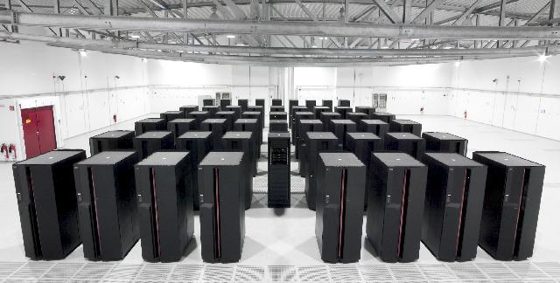

Figure 1. A Typical Supercomputer
Supercomputers, just like any other typical computer, have two basic parts. The first one is the CPU which executes the commands it needs to do. The other one is the memory which stores data. The only difference between an ordinary computer and supercomputers is that supercomputers have their CPUs opened at faster speeds than standard computers. This certain length of time determines the exact speed that a CPU can work. By using state-of-the-art materials being connected as circuits, supercomputer designers optimize the functions of the machine. They also try to have smaller length of circuits connected as possible in order for the information from the memory reach the CPU at a lesser time.
2. HARDWARE AND SOFTWARE DESIGN OF SUPERCOMPUTERS
As the main reason; due to supercomputers have innovative designs that allow them to perform many task in parallel, they are speedy than conventional computers. In fact, much of the performance difference between slower computers and supercomputers is due to the memory hierarchy. Because, their memory hierarchy is very carefully designed to ensure the processor is kept fed with data and instructions at all times. Their input/output systems tend to be designed to support high bandwidth, with less latency, because supercomputers are not used for transaction processing.
Supercomputers have been designed to do complex calculations at faster speeds than other computers. Its designers make use of 2 processes for the enhancement of its performance. The first method is called pipelining. It does complex operations at the same time by grouping numbers which have the same order that it calculates and these are passed to the CPU in an orderly manner. The circuits in the CPU continuously perform the operations while data is being entered into it.
Another method used is called parallelism. It does calculations in a similar than orderly way. This is where it performs various datas at the same time and moves ahead step by step. A usual way to do it is connecting together various CPUs which does calculations together. Each of these CPUs do the commands it needs to carry out on every piece of information.
All supercomputers make use of parallelism or pipelining separately or even combine them to enhance its processing speed. However, an increased demand for calculation machines brought upon the creation of the massively parallel processing supercomputers. It consists of various machines connected together to attain a high level of parallelism.

2.1 Supercomputer Challenges
- A supercomputer generates large amounts of heat and must be cooled. A typical TOP500 supercomputer consumes between 1 and 10 megawatt of electricity and converts all of it into heat. The cost to power and cool the system is usually one of the factors that limit the scalability of the system (for example, a high-end system such as Tianhe-1A could consume several million dollars worth of electricity per year).

- Information cannot move faster than the speed of light between two parts of a supercomputer. For this reason, a supercomputer that is many meters across must have latencies between its components measured at least in the tens of nanoseconds. In modern supercomputers built of many conventional CPUs running in parallel, latencies of 1–5 microseconds to send a message between CPUs are typical.

2.2 Technologies
- Several technologies have been developed for supercomputers such as vector processing, liquid cooling, nonuniform memory access, parallelization.

2.3 Processing Techniques
- Vector processing techniques were first developed for supercomputers and continue to be used in specialist high-performance applications. Vector processing techniques have trickled down to the mass market in DSP architectures and SIMD (Single Instruction Multiple Data) processing instructions for general-purpose computers.

2.4 Operating Systems
- Supercomputers today most often use variants of Linux. Changes in usage of supercomputer operating systems by years are shown in Figure 2, below.

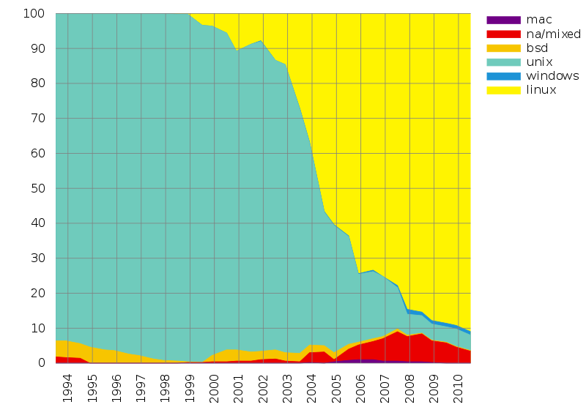

Figure 2. Operating Systems Used in Supercomputers

2.5 Programming and Software Tools
- The base language of supercomputer code is, in general, Fortran or C, using special libraries to share data between nodes.
- In the most common scenario, environments such as PVM and MPI for loosely connected clusters and OpenMP for tightly coordinated shared memory machines are used.
- Significant effort is required to optimize a problem; the aim is to prevent any of the CPUs from wasting time waiting on data from other nodes.
- Software tools for distributed processing include standard APIs such as MPI and PVM, VTL, and open source-based software solutions such as Beowulf, WareWulf and openMossix.
An easy programming language for supercomputers remains an open research topic in computer science.
Several utilities that would once have cost several thousands of dollars are now completely free thanks to the open source community that often creates disruptive technology.

3. MODERN SUPERCOMPUTER ARCHITECTURE
Supercomputers today often have a similar top-level architecture consisting of a cluster of MIMD multiprocessors, each processor of which is SIMD. The supercomputers vary radically with respect to the number of multiprocessors per cluster, the number of processors per multiprocessor, and the number of simultaneous instructions per SIMD processor. Within this hierarchy we have:
- A computer cluster is a collection of computers that are highly interconnected via a high-speed network or switching fabric. Each computer runs under an Operating System (OS).
- A SIMD processor executes the same instruction on more than one set of data at the same time. The processor could be a general purpose commodity processor or special-purpose vector processor. It could also be high-performance processor or a low power processor. As of 2007, the processor executes several SIMD instructions per nanosecond.

4. THE FASTEST SUPERCOMPUTERS TODAY
In general, the speed of a supercomputer is measured in "FLOPS" (Floating Point Operations Per Second), combined into the shorthand "TFLOPS" (1012 FLOPS, pronounced teraflops), or combined into the shorthand "PFLOPS" (1015 FLOPS, pronounced petaflops.)
"Petascale" supercomputers can process one quadrillion (1015) (1000 trillion) FLOPS. Figure 3 shows the change in speeds of supercomputers along years.

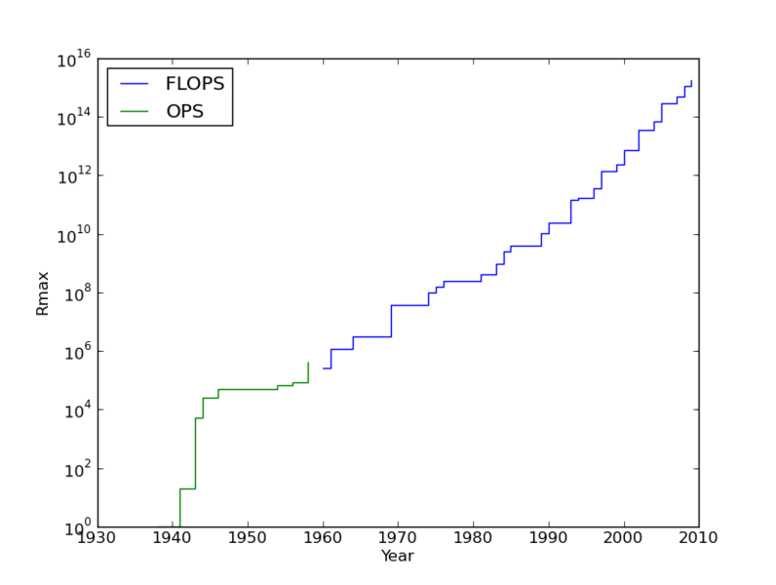

Figure 3. Fastest Supercomputers: log speed vs. years

Since 1993, the fastest supercomputers have been ranked on the TOP500 list. The list does not claim to be unbiased or definitive, but it is a widely cited current definition of the "fastest" supercomputer available at any given time.
Also, there is a journal about the supercomputers, named as The Journal of Supercomputing. It is an academic computer science journal concerned with theoretical and practical aspects of supercomputing. Tutorial and survey papers are also included.

4.1 TOP500 List Project
The TOP500 project ranks and details the 500 most powerful known computer systems in the world. It was started in 1993 and publishes an updated list of the supercomputers twice a year.
The list can be achieved at www.top500.or.
The TOP500 list is compiled by Hans Meuer of the University of Mannheim, Germany, Jack Dongarra of the University of Tennessee, Knoxville, Erich Strohmaier and Horst Simon of Lawrence Berkeley National Laboratory.
There is an application for the list of TOP 500 Supercomputers and it is very useful for understanding the TOP500 List. This application allows you to visualise the TOP500 list by the speed of each machine; the operating systems used; what it is used for; the country where it is based; the maker of the silicon chips used to build the machine and the manufacturer of the supercomputer. A snapshot from this application can be seen in Figure 4.
The application can be achieved at http://www.bbc.co.uk/news/10187248.
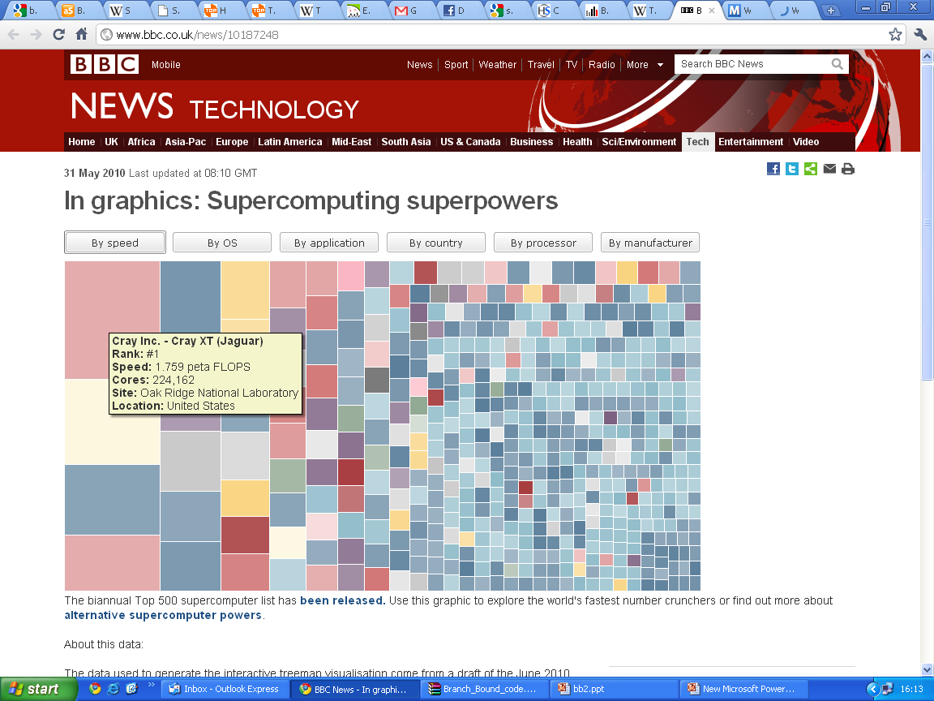

Figure 4. Classification of Supercomputers by Speed

4.2 Current Fastest Supercomputer
Since October 2010, the Tianhe-1A (shown in Figure 5), supercomputer has been the fastest in the world; it is located in China at the National Supercomputing Center in Tianjin. According to Nvidia, Tianhe-1A has achieved a processing rate of 2.507 petaflops, over 2½ quadrillion floating point operations per second. The second, Cray XT5 Jaguar (shown in Figure 6), has a processing rate of 1.759 petaflops. Also, Thianhe-1A has 186368 cores.
Tianhe-1A consists of;
- 14,336 Intel Xeon CPUs and 7,168 Nvidia Tesla M2050 GPUs with a new interconnect fabric.

- Tianhe-1A spans 103 cabinets, weighs 155 tons, and consumes 4.04 megawatts of electricity.

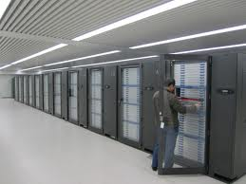

Figure 5. Tianhe-1A
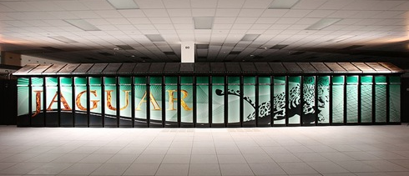

Figure 6. Cray XT5 Jaguar

REFERENCES
- http://en.wikipedia.org/wiki/Supercomputer
- http://www.top500.org/
- http://www.webopedia.com/TERM/S/supercomputer.html
- http://tr.wikipedia.org/wiki/S%C3%BCper_bilgisayar
- http://www.onlineticaret.net/site/page.asp?dsy_id=2624
- http://en.wikipedia.org/wiki/Top_500
- http://infosthetics.com/archives/2010/05/bbc_news_visualizing_the_top_500_supercomputer_report.html
- http://www.bbc.co.uk/news/10187248
- http://www.highbeam.com/doc/1G1-53256472.html
- http://www.essortment.com/all/supercomputersw_ppk.htm
- http://whatis.techtarget.com/definition/0,,sid9_gci213071,00.html

